MICRO SKILL CHALLENGE & STREAK BOARD
@CREATIVITY THINK (9483175986/7019689991)

ABSTRACT:
Micro Skill Challenge & Streak Board is a web-based platform designed to encourage continuous learning and skill development through daily and weekly challenges. Users participate in challenges, submit proof of completion, earn points, maintain streaks, and view leaderboards and badges. Administrators manage challenge creation, point rules, approve submissions, monitor participation rates, and export analytics. Built with Django and Django REST Framework for backend operations, and React with recharts and axios for frontend interactions, the system promotes engagement, motivation, and measurable skill improvement through gamified tracking..

INTRODUCTION OF THE PROJECT:
Learning new skills consistently is challenging without motivation and structure. Traditional methods of tracking progress in skill-based activities often lack visibility, reward mechanisms, and data-driven insights. The Micro Skill Challenge & Streak Board addresses these gaps by providing a centralized, gamified platform where participants can join challenges, track streaks, earn points, and monitor their progress. Administrators gain actionable analytics and oversight of submissions, ensuring fair participation and enhancing community engagement..

PROJECT OBJECTIVES:

• Provide a gamified platform for daily and weekly skill challenges
• Allow users to submit proof of completion (text, links, or images)
• Track user points, streaks, and progress over time
• Display leaderboards and award badges for achievements
• Enable administrators to create challenges and define point rules
• Review submissions, approve valid ones, and flag invalid entries
• Offer dashboards showing participation, completion rates, and analytics
• Allow exporting of challenge-wise data for performance evaluation
• Encourage consistent skill development and community engagement

PROBLEM OF THE STATEMENT:
Many learning communities struggle to maintain user engagement and track skill progression. Existing approaches lack structured tracking, gamification, and visibility into individual performance. Users may lose motivation without recognition, while administrators find it difficult to analyze participation and completion rates. This project addresses these issues by providing a structured, interactive, and analytics-enabled platform to track challenges, reward consistent efforts, and foster a competitive yet supportive learning environment..

MOTIVATION OF THE PROJECT:
• To create a gamified system for micro skill development
• To motivate users through points, streaks, and badges
• To simplify tracking and validation of challenge submissions
• To provide insights into community engagement and completion rates
• To enhance administrator oversight with dashboards and analytics
• To foster competition, collaboration, and continuous learning
• To provide a user-friendly interface for participants of all skill levels
• To export actionable reports for evaluation and recognition

BLOCK DAIGRAM OF PROJECT:

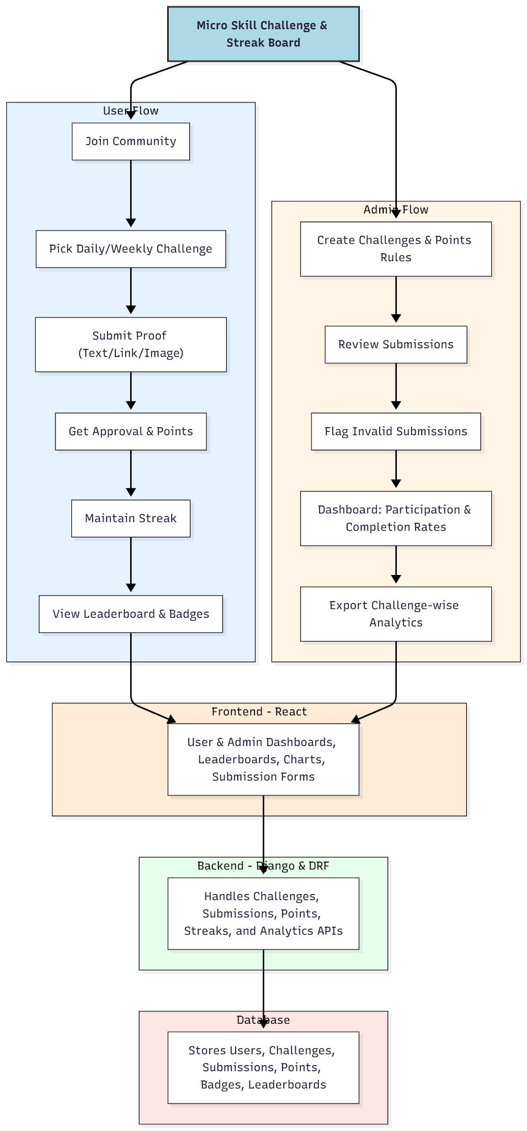

WORKING OF THE PROJECT:
Users join the community and select daily or weekly challenges. They submit proof of task completion, which is validated and approved by administrators. Points are awarded for approved submissions, and streaks are maintained for consecutive participation. Leaderboards and badges provide real-time motivation and recognition. Administrators create and manage challenges, define point rules, monitor submissions, flag invalid entries, and review participation analytics. The backend manages all API requests, stores submissions and user data, calculates points and streaks, and provides real-time updates to the frontend dashboards..

SOFTWARE REQUIREMENT:
- Backend:
  - Python 3.x
  - Django
  - Django REST Framework
  - SQLite/PostgreSQL
- Frontend:
  - Node.js and npm
  - React.js
  - Axios
- Development Tools:
  - Visual Studio Code
  - Postman (for testing APIs)
  - Git/GitHub (for version control)
- Server/Deployment (Optional):
  - Gunicorn, Nginx, or Heroku/AWS for hosting

ADVANTAGES OF THE PROJECT:

• Gamifies skill development through challenges, points, and badges
• Tracks user participation and streaks efficiently
• Provides leaderboards for motivation and engagement
• Allows administrators to monitor submissions and flag invalid entries
• Generates analytics dashboards for insights on completion and engagement
• Encourages continuous learning and community interaction
• Provides a professional, interactive, and responsive user interface
• Supports export of reports for evaluation and recognition

APPLICATIONS OF THE PROJECT:
• Coding clubs
• Art groups
• Language learning communities
• Educational institutions promoting skill practice
• Online/offline communities looking to encourage consistent participation

REFERENCES:

- Django REST Framework Documentation — Django Software Foundation. Django Documentation. Available: https://docs.djangoproject.com/
- Django REST Framework. DRF Documentation. Available: https://www.django-rest-framework.org/
- React. React Official Documentation. Available: https://reactjs.org/docs/getting-started.html
- Redux. Redux Documentation. Available: https://redux.js.org/introduction/getting-started
- PostgreSQL Global Development Group. PostgreSQL Documentation. Available: https://www.postgresql.org/docs/
- MySQL. MySQL Reference Manual. Available: https://dev.mysql.com/doc/
- Git. Git Documentation. Available: https://git-scm.com/doc
- Node.js. Node.js Documentation. Available: https://nodejs.org/en/docs/
- Axios. Axios Documentation. Available: https://axios-http.com/docs/intro
- Socket.io Documentation – https://socket.io/docs/

